NAME: JEEVITHA.S-192324020
DATA BASE MANAGEMENT SYSTEM FOR WEB APPLICATION(CSA0555)
37-Using Native Dynamic SQL to Recompile
PL/SQL Code
CREATE OR REPLACE PROCEDURE compile_plsql(
p_name VARCHAR2,
p_type VARCHAR2,
p_options VARCHAR2 DEFAULT NULL
) IS
v_stmt VARCHAR2(4000);
BEGIN
v_stmt := 'ALTER ' || p_type || ' ' || p_name || ' COMPILE';
IF p_options IS NOT NULL THEN
v_stmt := v_stmt || ' ' || p_options;
END IF;
EXECUTE IMMEDIATE v_stmt;
EXCEPTION
WHEN OTHERS THEN
RAISE_APPLICATION_ERROR(-20001, 'Error compiling PL/SQL object: ' || SQLERRM);
END;
/
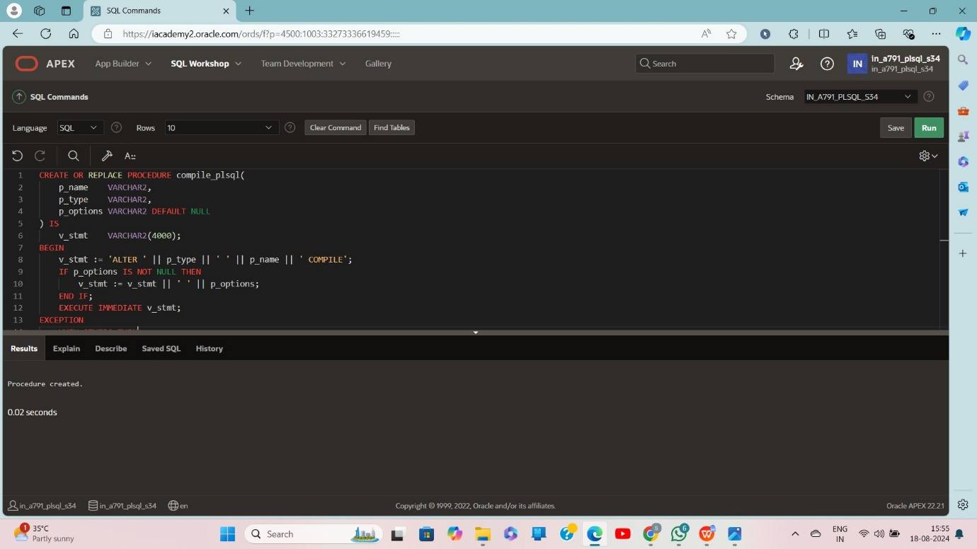
BEGIN
compile_plsql('format_phone', 'PROCEDURE');
compile_plsql('curs_pkg', 'PACKAGE', 'DEBUG');
END;
/ 